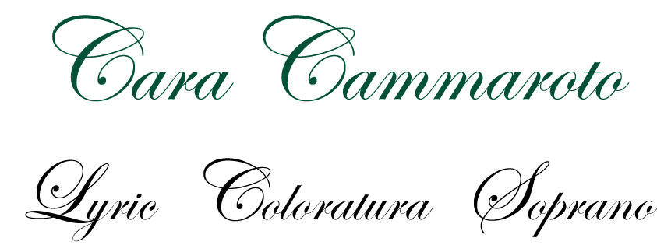

Cara Cammaroto is a lyric coloratura soprano who has performed in the U.S.,
Italy, Austria and Slovenia. She is considered a specialist in the bel canto style and ornamentation. Ms. Cammaroto is a featured artist at numerous festivals in the above mentioned countries. As a participant of the Bel Canto Institute, Ms. Cammaroto studied and performed many of the early roles featured in her most recent solo recording
Running Through The Years. Within the DC area, Ms. Cammaroto has been an active soprano soloist for a number of concert series and churches. She is the recipient of several notable awards including The Theodore Presser Foundation’s Presser Scholar Award, and The Pi Kappa Lambda National Music Honor Society.

Ms. Cammaroto holds a Bachelor of Music and a Master of Music in vocal performance from The Catholic University of America where she graduated Summa Cum Laude. During her years at CUA, she was awarded a music scholarship for both graduate and undergraduate studies. Vocal training includes: opera coaching with Dr. Michael Cordovana and Jane Bakken Klaviter; vocal instruction with Mary Ann Stabile and
Raymond McGuire; Master Classes with Renata Scotto and Dalton Baldwin.

